Abstract

Application that will allow you to order food & book a catering service within CIT installations

Quick & Eat

Requirements Engineering

SDA2, Group 4

Group Members:

Craig Andrews

Jamie Lawton

Conor Mulvey

Yaiza Costa Moreno

Contents

Elicitation Techniques 3

Brainstorming 3

Observation 4

Questionnaire 5

Prototyping 6

Description of business 7

List of goals 7

Vision Statement 8

Review of requirements elicitation techniques applied 8

Brainstorming 8

Observation 9

Questionnaire 9

Sample for users of the canteen 9

Sample for employees in the canteen & bistro 10

Prototyping 11

User Roles 11

Personas 11

Customers 11

Staff 12

Business Rules 13

Glossary 14

User Goals 14

Customer 14

Staff 14

List of use cases for each role 14

Description for each use case. 15

Chef 15

Customer 15

College Staff 15

Canteen Assistant 15

Usage scenarios for application 16

Usage Scenario 1 Chef wants to remove items from the menu of the day 16

Usage Scenario 2 Customer wants to order a meal. 16

Usage Scenario 3 Registered lecturer (John) orders food for the staff canteen 16

Usage Scenario 4 Canteen Assistant checks for orders. 16

Evaluation of the prototype 17

Mark – Customer, Student 17

John- Customer, Lecturer 17

**Jeff- Canteen Assistant** 18

# Elicitation Techniques

## Brainstorming

**a. Student name**

Jamie Lawton

**b. Elicitation Technique: Brainstorming**

Brainstorming involves people sharing known information for the benefit of the group. It can also be used by a single person to aggregate their own knowledge and to get their mind on the right track.

Where it is used for a group its implementation can vary. People can take it in turns to volunteer their opinion, one-by-one around the room. Alternatively, the discussion can be more open. In the latter case there can still be rules which help to keep the session organised, such as having an informal chairperson or a general policy that only one person may speak at a time.

Brainstorming was popularised in 1953 by Alex Osborn who described it as a technique whereby a group “attempts to find a solution for a specific problem by amassing all the ideas spontaneously by its members.”

Brainstorming is best used for high-level idea generation. The specifics of the captured requirements can be refined later in the process.

**c. Advantages & Disadvantages**

**Advantages:**

The advantages of brainstorming lie in its easiness to implement. It is cheap and easy to understand. It helps to generate new ideas and get answers to outstanding issues. It allows all the stakeholders to be involved in the requirements elicitation process. It creates an environment where people’s opinions can be voiced without judgement.

By involving as many people as is practical, brainstorming can be used to capture requirements and processes that otherwise might not have been considered. This can prevent surprises later in the project.

**Disadvantages:**

If the brainstorming is not organised properly, it can be easy to lose control of the process. If the session becomes hectic, people may not want to speak their opinion. Some people will be naturally more inclined to speak out and may dominate the session. If the group is too large many people may try to volunteer their ideas at the same time.

Ideas generated in this kind of forum can be ambiguous or misunderstood as they are not discussed in any meaningful detail.

**d. Applicability of the technique to the project:**

In the case of Problem 1 (The Canteen Meal ordering mobile application), it is important to receive at least some high-level input from canteen staff and students. If the requirements for this project were only the result of interactions between the developers and college administrators, then certain requirements could be overlooked.

Input from canteen staff might be required to know how best to utilise the data captured by the app to decide how much food to prepare in order to reduce food wastage. The requirement for the ability to handle dietary requirements might go without saying, but it would be easy to forget the need to handle culturally or religiously imposed dietary restrictions such as Halal and Kosher traditions without a diverse pool of canteen users involved in the requirements elicitation process, as an example.

Both sets of people should also be able to weigh in on decisions such as whether to allow food to be obtained without the app, and if so, whether there should be a separate queue in the canteen and how that would be implemented, for example.

The ability to quickly and easily capture requirements information from people with different levels of understanding about the IT, culinary and administrative elements of this project makes brainstorming particularly suitable.

## Observation

**a. Student name**

Craig Andrews

**b. Observation:**

Observation is the action or process of carefully watching someone or something. An observation is something that you have learned by seeing or watching something and thinking about it. Observation may be done passively or actively. Passive/Invisible observation happens where the analyst has no interaction with the worker while the observation is going on but takes notes. The analyst would typically ask follow-up questions after the observation session by using a prepared list of questions or asking questions on the fly. With active/visible observation, the analyst can interrupt the worker to ask questions during the observation session. In some cases, the observer may participate in the activity as an apprentice.

**c. Pros & Cons of the Observation Technique:**

Pros:

* The data gathered during observation sessions are quite reliable; it is often used to confirm the data extracted using other techniques
* Observation can be used to extract information on the physical environment where the task is performed. For example, the analyst can get information on level of noise, physical layout, traffic and so on
* It is relatively inexpensive
* It allows the analyst to perform work measurements

Cons:

There are however, some downsides to using the observation technique that you should be aware of. One is that exceptions are difficult to capture in one session; repeated observation sessions and interviews may be needed to supplement the facts gathered. Observers are also prone to bias reflected in the form of seeing what they expect to see and what they want to see, which can affect the results of the observation.

## Questionnaire

**a. Student name**

Conor Mulvey

**b. Description of elicitation technique**

The elicitation technique I have chosen a questionnaire. Questionnaires are never useful tools for collecting large amounts of data from a wide range of users. It involves creating a list of questions, the answers to which will provide useful data needed for your research, and then asking potential users to answer these questions. It can be online or handed out as physical copies.

**c. Advantages and Disadvantages**

Advantages:

* Questionnaires allow us to gather a large amount data in a relatively short amount of time.
* It is an inexpensive way to collect data.
* Allows us to collect the exact data we need
* Well thought out questions will give us clear, quantifiable answers

Disadvantages:

* It can be quite difficult to word the questions correctly. If a user misinterprets the question, then the data they provide damages the overall research. We should begin by running a trial on a small number of users to ensure it works.
* Low response rate. We could possibly offer an incentive an incentive to encourage participation, such as a free canteen lunch.

1. **Applicability of the technique to your project.**

For our project a questionnaire would fit our project very well as all our potential users gather in the canteen at predictable times. This means we know exactly where to focus data collection efforts. We would look mainly for information on which students are arriving for a small break between lectures and which students are looking for full dinners during long breaks. Information such as this will give us an idea of when the busiest times in the canteen are and what sorts of food is being ordered at these times. This will also help pick which foods will be available in the app so as not to create more food waste. We can also include questions to figure out the main cause of food wastage such as whether too much food is being prepared or the portions are too large. By adding a simple suggestion box at the bottom of the survey we can also gain an idea of what the users would like to see in the finished product.

## Prototyping

**a. Student name**

Yaiza Costa Moreno

**b. Description of elicitation technique.**

Prototyping involves presenting a mock-up or a first design of a software, this will help the developers, and customers to understand the requirements better. As customers, or stakeholders on occasions we are not sure of what we want or need until we see how could look like, from there we can suggest modifications that will help the software to improve, and as developers following that interaction and participation from both sides we could set a list of priorities that can be adjusted following our budget and time too.

Prototyping could provide mock-ups using different approaches, from using paper prototypes to use interactive prototypes.

**c. Advantages/Disadvantages of this technique**

Advantages:

* Provide a better understanding of the software functionality.
* The improvements suggested while the process of analysing the mock-up give more specific solutions based on that first/s prototypes.
* Improve the communication required between programmers to the successful completion of the project, without prototyping there is a risk of building an inadequate system.

Disadvantages:

* Require high time investment at the beginning, because of the time that will take to develop a prototype.
* It could get difficult to focus on the main goals and issues and start discussing specific details of the application.
* The customer and stakeholders may not consider the possibility of the variations between the mock-up and the final product.

**d. Applicability of the technique to your project.**

Prototyping, will help us to show a mock-up to the customers, stakeholders so they can get an idea of how the final product/application is going to be, this is very important because users may not be aware of what they need, or how this application could improve their process of ordering/preparing meals. Also, it will help the users to understand the positive impact this application can bring to their daily routines.

In this case, main canteen and Bistro staff will need to have basic knowledge of how computers work to understand and follow through the orders, and once the order is made to make that order as completed. While prototyping we can present to the staff and customers the basics of how the system will work and see if our expectations are realistic and we are building an application that is clear an easy to use.

**d. Applicability of the technique to your project.**

I think the elicitation technique of observation is a good technique for the problem in the cafeteria as it’s easy to perform and very accurate, for example I can check the queue of each shop three times a day to see when it’s at its busiest etc.

# Description of business

The business domain in which the IT system is being developed is for the various shops and canteens located in the Cork Institute of Technology. CIT has currently 6 shops on campus that all operate each day, beginning roughly at 8am. However, with there being so much students on site it can lead to ridiculously long queues to get food. Students sometimes spend nearly half there break in a queue, which shouldn’t really be happening as it puts unnecessary pressure on students but also on the shop staff. The current situation we the long queue times was the triggering catalyst leading to the overhaul of the queuing system.

Also the process of requesting a catering service for a lecturer it takes too long, at the moment the lecturer has to contact the head of department by email, wait for their response and then if approved send another email to bistro and wait for their confirmation. Adding a section where the lecturer could send the request to the appropriate head of department and once the received the approval finishing the request and send it to bistro and received an automatic response will make this process faster, and the lecturer could keep track of all these process within an unique application.

# List of goals

With the introduction of the Quick & Eat app, which will allow students to place an order and simply pick it up when it is ready, we predict:

1. Reduction of queuing/wait times of up to 50%. This 50% reduction will allow students to enjoy their meal or even get more study.

2.Reduce the use of cash within the food installation in CIT by 60%, this will reduce the amount of trips to the bank to deposit that money into their business account.

3.Reduce food wastage 20%, because with this application the CIT staff could study patrons in their orders and adjust the quantities of meals to the “expected” orders of the day.

# Vision Statement

**For** students and employees of CIT

**Who** require a quick way/process of ordering their meals

**The** Quick & Eat

**Is** a meal ordering application

**That** will allow them to order their meals before arriving to the canteen or Bistro, then the staff will set a timer and once your food is ready it will send you a notification, so customers can user their time effectively instead of waiting

**Unlike** the current system, that make customers wait in long queues in the busiest hours

**Our product** will help you to use your time efficiently, and order before even arriving to the canteen or Bistro.

# Review of requirements elicitation techniques applied

## Brainstorming

Brainstorming was used to generate ideas for the questionnaire, and again to discover requirements for the canteen ordering system.

The group went through a brainstorming session before producing the questionnaire. Ideas were generated concerning the questions that should be on the questionnaire and the people to whom the questionnaire should be given. It was decided that one questionnaire would be made to be given to canteen customers and another would be made for the staff, as the requirements for each of those types of user would be so different that most questions would only apply to one of them.

Brainstorming was also used to capture requirements for the system itself. This helped to illustrate the main features that would be required for the system at a high level. For example, staff needed to be able to view order totals so that they could determine how much food to prepare in an effort to reduce food waste and expenses. On a logistical level they also needed training, or at least a briefing, on any changes that they would see in their jobs once the system was implemented. Students (customers) needed to be able to view the available meals (including dietary information), order a meal, and manage their balance (to include viewing balance and topping up).

There were a few difficulties with brainstorming. The requirements of the canteen staff and of the customers were so different that there were effectively two distinct brainstorming sessions taking place at the same time. The data obtained from the session is also quite high-level and the finer details still need to be considered. Does the customer balance for the app have anything to do with the balance on the CIT student card? How does the customer go about claiming their order when they get to the canteen? How do the staff at the payment counter distinguish between customers who have already paid using the app and customers who ordered conventionally at the food counter and have yet to pay?

## Observation

The elicitation technique I chose was observation, I decided the best way to get my data/info was to just watch the lines at the various shops around the campus. My friend, who uses the shops/canteen daily, decided to help me. I would observe the length of time it took him to order his food etc. I did this from Monday to Thursday, observing my friend in the queue and he was roughly waiting 17-25 minutes from the time he entered the queue to the time he sat down at the table, this could be partly due to the busy time of day and the weather on the days of the observation. I continued my observation of the shops when I could and came up with some more problems that I hadn’t seen the first time around:

1. Some students queue at the beginning of the canteen, even when they want food from different sections, increasing their time waiting.
2. Depending of the day there is no breakfast available after 11-11:30, and this is very inconvenient for some people that want to have a full Irish breakfast – loss of money from the point of view of the canteen because the customer will leave and buy breakfast somewhere else.
3. Some people leave the canteen without paying, having this pre-order and paying method this will not be possible.

## Questionnaire

### Sample for users of the canteen

Where options are provided, please circle answer

1. How many times a week do you eat in the canteen/bistro?
2. At time do you usually go to the canteen?



1. Do you usually know what you want to eat before arriving to the canteen?

Yes No

1. How long do you usually spend in the process of queuing, ordering and paying for your food?



1. Do you find that this is an acceptable amount of time?

Yes No

1. What is your favourite item to purchase?



1. Do you get your food to go or to eat in the canteen?

To go Eat in

1. Do you find that regularly leave behind food waste?

Yes No

1. If yes, why?



1. How likely would you like to have an application that will allow you to order and pay before arriving to the canteen?

Very Likely Likely Unsure Unlikely Very Unlikely

1. Is there any feature you would specifically like to see in this app?



### Sample for employees in the canteen & bistro

Where options are provided, please circle your answer.

1. What times do you find are the busiest?



1. What items are most popular?



1. Do you find that over preparation of some foods results in food wastage?

Yes No

1. Do you think allowing students to order their food in advance would help solve some of these problems?

Yes No

1. What foods would you allow students to order in terms of popularity and time it takes to prepare?



## **Technique application**

Once we had settled on which questions we would include in the survey we then printed out several of them and handed them out to some of our fellow students and various members of the canteen and bistro staff. Once we had a collected all the completed surveys we reviewed them and recorded the data.

## Prototyping

This elicitation technique required the use of a software, in this case, Pencil.

The prototypes are attached as a Pencil project.

# User Roles

Customers – Students, teachers.

Staff – Employees of the CIT canteen, bistro and catering.

# Personas

## Customers

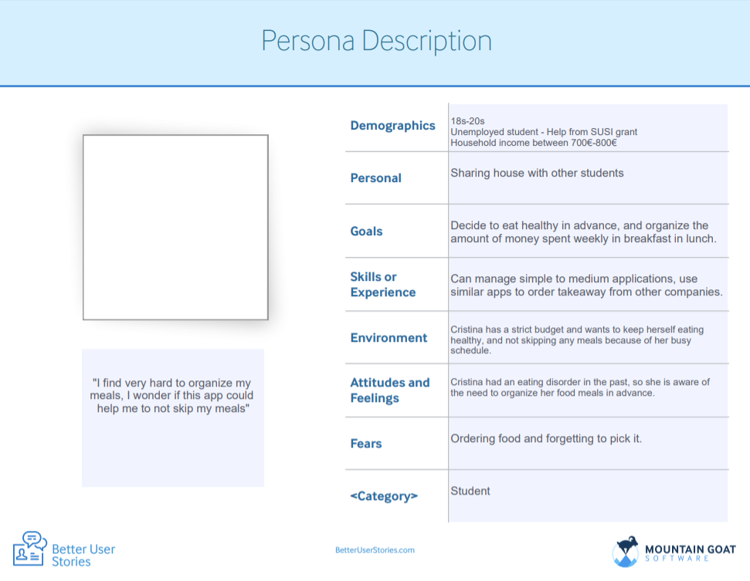

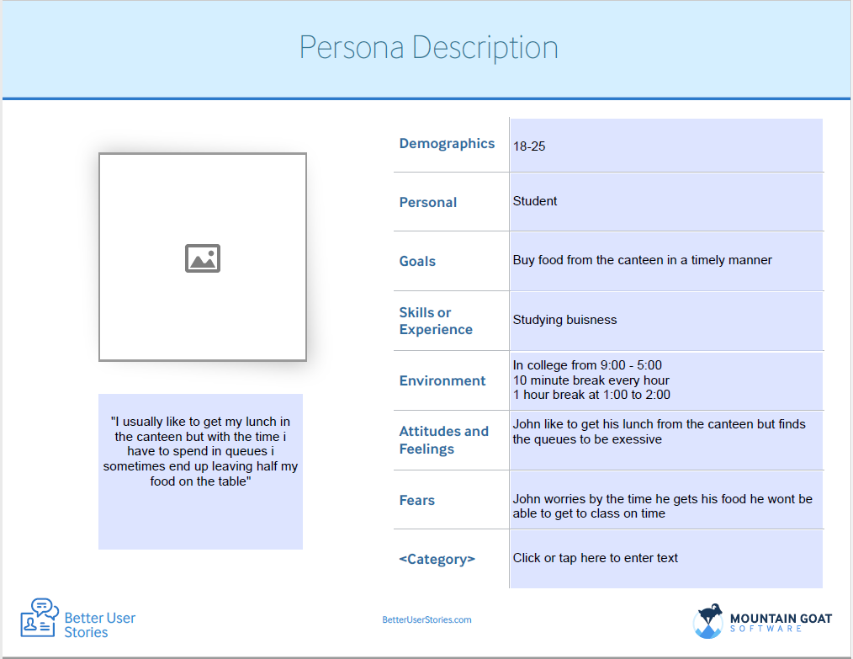

## Staff

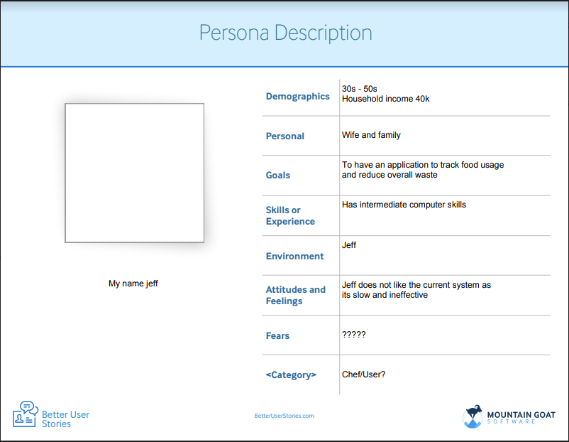

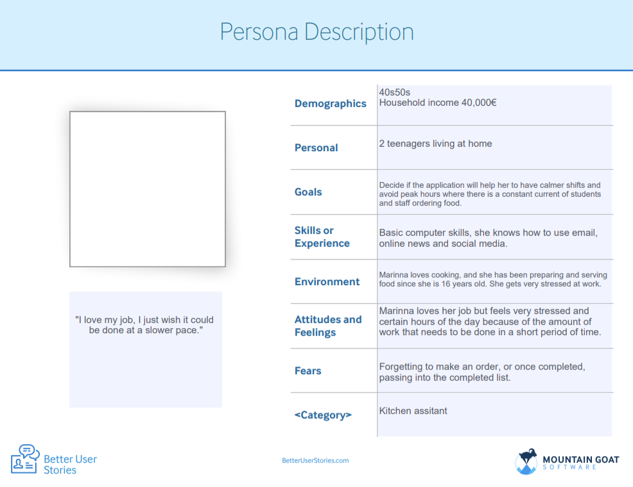

# Business Rules

|  |  |
| --- | --- |
| Security/Encryption | As the users will be required to use their credit cards to top up their account then we will have to have very good confidentiality when handling their data, on the topic of data, it won’t be out sourced or sold to third party organizations. To protect the financial information of the user we will be using a 128-bit encryption. |
| Canteen Policy | Order price is calculated as the sum of each food item price times the quantity of that food item ordered. All meals are collected only in the collection assigned area, once the order has been done, customer must present an order identification number. Only canteen employees who are designated as food administrator can create modify, delete items from the daily menu in the application. Pre-orders must be done between 8am and 5pm for the same day. |
| Health and Safety | The chefs will be acquiring the freshest ingredients from on the most trusted and local of sources. The food will be handled and cooked in a sterile environment. |

# 

# Glossary

Staff: all the employees of CIT that contribute to the food preparation, ordering, serving process.

Customer: all the persons including students and teachers, that buy goods/ meals from the canteen.

Canteen: It refers to the area where customers pick their food and eat it, if they wish.

Order: Request of a service, in this case a meal from the canteen.

# User Goals

## Customer

* Ability to pre order meals for the day.
* Browse through the application type of meals available
* Access to promotions/ specials
* Check for orders history
* Top up account

## Staff

* Check for number of daily orders
* Check the organization of the orders by the time the customer wants to receive it
* Access to summarize of the orders of the day.

# List of use cases for each role

Chef

1. Remove items from the menu
2. Add items to the menu
3. View food orders

Customer

1. View the Food Menu
2. View the Specials & Promotions
3. Order a Meal
4. Top Up Account

College Staff (e.g. Lecturer)

1. Browse menu
2. Place Order
3. Top up Account
4. Request Catering Services

Canteen Assistant can:

1. View food orders
2. View order schedule
3. Summarize orders

# Description for each use case.

## Chef

1. Remove items from the menu: A chef selects the items that are not available in the menu of the day.
2. Add items to the menu: A chef add new items to the menu, that were not available before.
3. View food orders: A chef can view food orders.

## Customer

1. View the Food Menu: A customer can view the available options for the day, including the prices and dietary information.
2. View the Specials & Promotions: A customer can view the special deals and menu items for a particular day, including prices and dietary information.
3. Order a Meal: A customer can select a meal and specify a time. Their order is placed and their balance is deducted.
4. Top Up Account: Customer may use a credit/debit card to top up their canteen ordering account.

## College Staff

1. Browse Menu – If a lecturer would like to see what is available to order today, the app should provide a clear and accurate menu.
2. Place Order – Once a lecturer has picked out an item, they should be able to place an order for that item which lets the canteen staff know what item they must prepare.
3. Top up Account – A lecturer should be able add money to their account, so any payments can be processed through the app instead of waiting in line in the canteen.
4. Request Catering Services – If lecturer has guests coming to the college, they can send a request through the app. The year head can then see this request and approve it they the canteen staff can be notified and begin preparations.

## Canteen Assistant

1. View food orders: The canteen assistant can view the orders that come it throughout the day
2. View order schedule: The canteen assistant can view the order list in the order they came in.
3. Summarize orders: The canteen assistant can summarize the orders that came in the day to see the most bought item etc.

# Usage scenarios for application

Usage Scenario 1 Chef wants to remove items from the menu of the day

1. Chef enter identification username and password
2. SYSTEM validates the information
3. SYSTEM show the menu options
4. Chef select the items that are not available in the menu that day
5. SYSTEM remove the items
6. SYSTEM modify status from those items, from available to unavailable
7. Chef log out

Preconditions: A Chef must have an account with specific credentials to be able to modify the menu.

Post-Conditions: If the use case was successful, the employee information is added, updated, or deleted from the system. Otherwise, the system state is unchanged.

Usage Scenario 2 Customer wants to order a meal.

1. Customer selects an item from the menu.
2. SYSTEM prompts the Customer to specify the time they would like to collect the meal.
3. Customer enters the time.
4. SYSTEM validates the time (it must be at least an hour ahead of the current time)
5. SYSTEM informs customer that their order was successfully placed

Preconditions: The customer was already logged into the system and browsing the food menu. This requires a valid account.

Post-Conditions: The order is added to the canteen staff’s schedule and the customer’s balance is deducted by the price of the meal.

## Usage Scenario 3 Registered lecturer (John) orders food for the staff canteen

1. John opens the app and enters his username and password into the fields provided
2. *System* The system then validates this information.
   1. If is valid
   2. User is moved to the home page providing them with options of where they would like to order form.
3. John then clicks on the staff canteen button.
4. *System* Displays the available menus for that area.
5. John selects what they would like to order and at what time then clicks confirm.
6. *System* prints the ordered items on screen to confirm with the customer this is what they ordered.
7. John clicks on confirm.
8. *System* sends the order to the canteen staff.

Pre- conditions: John is registered with the app already

Post-conditions: I the case is successful then an order will have been placed with the canteen staff.

## Usage Scenario 4 Canteen Assistant checks for orders.

1. Jeff logs into the app using his info.
2. System prompts a successful login and displays the home screen.
3. Jeff clicks the “check orders” button.
4. System displays the “check orders” page.
5. Jeff can view the orders that came in.
6. Jeff clicks the “exit” button.
7. System prompts successful exit.
8. Jeff clicks the “log out” button.
9. System prompts successful log out.

# Evaluation of the prototype

## Mark – Customer, Student

1. **Name of person** - Mark
2. **What role did they play?** – Student in CIT – eats in the canteen 3 times a week.
3. **Where evaluation took place** – CIT canteen
4. **Feedback What they liked. What they didn’t like or want** –

Small numbers or steps from the login part to the order completion. Also, the idea that the money will be deducted from his CIT card.

Complexity from the point of view of staff, they may don’t have enough time or knowledge having to update the different sections every morning, also Mark did not like the way  the items are organized, he prefers something more simplistic. The size of the buttons and number of pictures displayed.

1. **Suggestions for improvement**.

Having a dropdown menu with foods available.

## John- Customer, Lecturer

i.                     **Name of person** - John

ii.                   **What role did they play?** – Lecturer in CIT – eats in canteen 4 days a week

iii.                 **Where evaluation took place** – CIT staff canteen

iv.                 **Feedback What they liked, what they didn’t like or want** –

John said he really liked how the app speeds up the process, as some days he felt the need to skip his lunch in order to get his work done but the app has helped solve this. He also found the app made organizing catering much easier.

v.                   **Suggestions for improvement**. Greater variety of foods.

## 

## Jeff- Canteen Assistant

i.                     **Name of person** - Jeff

ii.                   **What role did they play?** – Chef at CIT

iii.                 **Where evaluation took place** – CIT canteen

iv.                 **Feedback What they liked. What they didn’t like or want** –

Small numbers or steps from the login part to the order completion.

Ease of use, seemed to like the setup of the app.

v.                   **Suggestions for improvement**.

Food usage tracker? To track the amount of food used for the day.